

BI Solution Proposal

Researching of

the World Bank funding

Document Revision History

|  |  |  |  |
| --- | --- | --- | --- |
| Version | Date | Updated by | Comments |
| 0.1 | 23.07.2013 | Anzhela Papova | Initial Version |
|  |  |  |  |
|  |  |  |  |
|  |  |  |  |
|  |  |  |  |
|  |  |  |  |
|  |  |  |  |

CONTENTS

1. Overview 3

1.1. Business Background 3

1.2. Benefits 3

2. Requirements 4

2.1. Business Requirements 4

2.2. Technical Requirements 4

3. Solution Sketch 5

3.1. Source Tables structure 5

3.2. Summarize Data Plan 8

4. DWH Solution Concept 8

4.1. Logical Diagrams 9

4.2. Physical diagrams 10

# Overview

The World Bank is a source of financial and technical assistance for developing countries. The World Bank is made up of two unique development institutions owned by 187 member countries — the International Bank for Reconstruction and Development (IBRD) and the International Development Association (IDA). These institutions play different but collaborative roles to advance the vision of an inclusive and sustainable globalization. The IBRD focuses on middle-income and creditworthy poor countries, while IDA focuses on the poorest countries. Together they provide low-interest loans, interest-free credits, and grants to developing countries for a wide array of purposes, including investments in education, health, public administration, infrastructure, financial and private sector development, agriculture, and environmental and natural resource management.

The current Solution Proposal includes Business Background, Requirements and Solution sketch for The World Bank analyzing allocation of funds within programs and countries.

## Business Background

The aim of this project is to identify unjustified country financing by the World Bank. The World Bank accumulates funds from various sources and invests them different countries (within programs). This is matched to ambitious goals of The World Bank Group – to end extreme poverty within a generation and boost shared prosperity.

For each program are defined the purpose, duration and leader – manager who responsible for the reasonable allocation of funds within program. Manager appointed for a fixed period of time. One program can include financing of several countries. Financing of each country during one year can be carried out within one program.

The World Bank provides financial assistance to countries not more often than once a month in a single tranche. One tranche for one country has one finance source.

The possibility of financing is determined by level of the country's budget deficit. The level of the country's budget deficit is defined as the ratio of the deficit / surplus of the budget to the index of gross domestic product (GDP) for the period, expressed as a percentage. Deficit/ surplus of the budget is determined as the difference between revenues and expenses of the country’s government. Government excludes public corporations and quasi corporations (such as the central bank). Units of government at many levels meet this definition, from local administrative units to the national government.

The level of the budget deficit of the country is ranked in groups. World Bank funds cannot be allocated to countries with a budget surplus or low level of the budget deficit in the 12 months preceding the date of disbursement.

The final decision about financing is made by the program manager (by adopting the appropriate order). Funds are disbursed in the month of approval of the relevant order.

The purpose of this project is to provide customer with analytical information about country financing by the World Bank within programs (and their managers) to identify unjustified financing (to countries with a budget surplus or low level of the budget deficit in the 12 months preceding the date of disbursement).

## Benefits

Researching of the World Bank funding will help:

* to identify those program managers who made the final decision about financing countries with a budget surplus or low level of the budget deficit in the 12 months preceding the date of disbursement;
* to identify program managers who always made the correct decision about financing countries.

Thus the researching will help to optimize managers’ structure and to improve the distribution of financial resources between the countries with the objective of achieving the purposes of the World Bank.

# Requirements

## Business Requirements

Business requirements of this project are listed below.

BR1. To get monthly information it’s necessary to create dimension DIM_TIME_MM with structure: MONTH_ID, MONTH_DESC, QUARTER_ID, QUARTER_DESC, YEAR_ID, YEAR_DESC.

BR2. To get information by countries and regions it’s necessary to create hierarchy dimension DIM_COUNTRIES with structure: COUNTRY_ID, COUNTRY_DESC, REGION_ID, REGION_DESC.

BR3. To get information about financing by sources it’s necessary to create dimension DIM_FIN_SOURCES with structure: FIN_SOURCE_ID, FIN_SOURCE_DESC.

BR4. To get information about financing within programs and their managers it’s necessary to create hierarchy dimension DIM_PROGRAMS_SCD with structure: PROGRAM_ID, PROGRAM_CODE, PROGRAM_DESC, MANAGER_ID, MANAGER_DESC, VALID_FROM, VALID_TO. Type of dimension DIM_PROGRAMS_SCD is SCD type 2. So it’s necessary to add the next columns: PROGRAM_SURR_ID, IS_ACTIVE.

BR5. To range information by groups of deficit level it’s necessary to create dimension DIM_GEN_DEF_LEVELS with structure: DEF_LEVEL_ID, DEF_LEVEL_CODE, DEF_LEVEL_DESC, LOWER_VALUE, UPPER_VALUE.

BR6. To storage and extract analytical information it’s necessary to create fact table FCT_WB_FIN_COUNTRIES_MM containing fact columns FIN_AMOUNT, GDP, BUD_DEFICIT which depend on dimensions: DIM_TIME_MM, DIM_COUNTRIES, DIM_FIN_SOURCES, DIM_PROGRAMS_SCD, DIM_GEN_DEF_LEVELS.

BR7. Government finance statistics (values of columns FIN_AMOUNT, GDP, BUD_DEFICIT) are stored and reported in USD.

BR8. Level of granularity information in the fact table – monthly.

BR9. In the fact table data should be loaded and stored since 2000.

BR10. Data should be updated monthly by overwriting data for previous 12 months.

Structure of dimensional and fact entities might be changed during BI Solution Concept creation.

## Technical Requirements

Technical requirements of this project are listed below.

TR1. All objects should be named according to the Initial Guidelines of Star Aggregation Layer Modeling.

TR2. Every dimensional and fact table should contain last time changed information columns: INSERT_DT (date of row creation) and UPDATE_DT (date of last time row modification).

TR3. Data about financing of particular country should be updated at night according to the distribution of time zones.

TR4. Data warehouse should be monthly backed up at night according to the distribution of time zones on the day before updating.

# Solution Sketch

## Source Tables structure

Data on government revenue and expense are collected through questionnaires to member countries and by the Organization for Economic Cooperation and Development.

Schema <ANALITICS> is used as source system where data is physically stored and used to analytical needs.

Source tables structures are presented in tables below.

**Table 3.1 Finance sources**

|  |  |  |
| --- | --- | --- |
| Column_name | Data_type | Comment |
| Fin_source_ID | NUMBER | Finance source code |
| Fin_source_name | VARCHAR2(100) | Finance source name |

This table contains information which should be loaded in dimensional entity DIM_FIN_SOURCES.

**Table 3.2 Programs**

|  |  |  |
| --- | --- | --- |
| Column_name | Data_type | Comment |
| Program_code | VARCHAR2(10) | Program code |
| Program_name | VARCHAR2(100) | Program name |
| Program_purpose | VARCHAR2(200) | Program purpose |
| Manager_FN | VARCHAR2(50) | Program manager first name |
| Manager_LN | VARCHAR2(50) | Program manager last name |
| Start_date | DATE | Date of appointment |
| End_date | DATE | Date of validity |

This table contains information which should be loaded in dimensional entity DIM_PROGRAMS_SCD.

Ranging information by groups of deficit level is made by analytics using special table with constant values. Structure and values which should be loaded in dimensional entity DIM_GEN_DEF_LEVELS are presented below.

**Table 3.3 Dimensional entity DIM_GEN_DEF_LEVELS**

|  |  |  |  |  |
| --- | --- | --- | --- | --- |
| Def_ level_ID | Def_level_code | Def_level_desc | LOWER_VALUE | UPPER_value |
| 1 | Lower 60% | Extremely high | -999,99 | -60,00 |
| 2 | 20-59,99% | High | -59,99 | -20,00 |
| 3 | 3-19,99% | Middle | -19,99 | -3,00 |
| 4 | 0-2,99% | Low | -2,99 | 0,00 |
| 5 | Surplus | Surplus | 0,01 | 999,99 |

**Table 3.4 Fact_financing**

|  |  |  |
| --- | --- | --- |
| Column_name | Data_type | Comment |
| Date | DATE | Date of fact financing |
| Country | VARCHAR2(100) | Country name |
| Program_code | VARCHAR2(10) | Program code |
| Fin_source_ID | NUMBER | Finance source code |
| Amount | NUMBER | Disbursement amount |
| Loan_charge | NUMBER | Loan charge, % |
| End_date | DATE | Plan return date |

This table contains information (column AMOUNT) which should be loaded in fact entity FCT_WB_FIN_COUNTRIES_MM (column FIN_AMOUNT).

**Table 3.5 GDP_countries**

|  |  |  |
| --- | --- | --- |
| Column_name | Data_type | Comment |
| Year | VARCHAR2(4) | Year |
| Month | VARCHAR2(30) | Month name |
| Country | VARCHAR2(100) | Country name |
| GDP | NUMBER | GDP |

This table contains information which should be loaded in fact entity FCT_WB_FIN_COUNTRIES_MM (column GDP).

The next two tables used to derive column BUD_DEFICIT in fact entity FCT_WB_FIN_COUNTRIES_MM. Calculation procedure is presented in chapter Summarize Data Plan.

**Table 3.6 Finance_items**

|  |  |  |
| --- | --- | --- |
| Column_name | Data_type | Comment |
| Fin_item_ID | NUMBER | Finance item code |
| Fin_item_name | VARCHAR2(100) | Finance item name |

This table contains information about types of government revenues and expenses.

Government activities are financed mainly by taxation and other income transfers, though other financing such as borrowing for temporary periods can also be used (revenue). Government revenues consist of:

* Taxes on income, profits, and capital gains - levied on the actual or presumptive net income of individuals, on the profits of corporations and enterprises, and on capital gains, whether realized or not, on land, securities, and other assets. Intragovernmental payments are eliminated in consolidation.
* Taxes on goods and services - include general sales and turnover or value added taxes, selective excises on goods, selective taxes on services, taxes on the use of goods or property, taxes on extraction and production of minerals, and profits of fiscal monopolies.
* Taxes on international trade - include import duties, export duties, profits of export or import monopolies, exchange profits and exchange taxes.
* Other taxes - include employer payroll or labor taxes, taxes on property, and taxes not allocable to other categories, such as penalties for late payment or nonpayment of taxes.
* Social contributions - include social security contributions by employees, employers, and self-employed individuals, and other contributions whose source cannot be determined. They also include actual or imputed contributions to social insurance schemes operated by governments.
* Grants and other revenue - include grants from other foreign governments, international organizations, and other government units; interest; dividends; rent; requited, nonrepayable receipts for public purposes (such as fines, administrative fees, and entrepreneurial income from government ownership of property); and voluntary, unrequited, nonrepayable receipts other than grants.

Expense is cash payments for government operating activities in providing goods and services. It includes compensation of employees, interest and subsidies, grants, social benefits, and other expenses such as rent and dividends. Government expenses consist of:

* Goods and services - include all government payments in exchange for goods and services used for the production of market and nonmarket goods and services. Own-account capital formation is excluded.
* Compensation of employees - include all payments in cash, as well as in kind (such as food and housing), to employees in return for services rendered, and government contributions to social insurance schemes such as social security and pensions that provide benefits to employees.
* Interest payments - include payments made to nonresidents, to residents and to other general government units for the use of borrowed money.
* Subsidies and other transfers - include all unrequited, nonrepayable transfers on current account to private and public enterprises; grants to foreign governments, international organizations and other government units; social security, social assistance benefits and employer social benefit s in cash and in kind.
* Other expense - include spending on dividends, rent, and other miscellaneous expenses, including provision for consumption of fixed capital.

**Table 3.7 Finance_countries**

|  |  |  |
| --- | --- | --- |
| Column_name | Data_type | Comment |
| Year | VARCHAR2(4) | Year |
| Month | VARCHAR2(30) | Month name |
| Country | VARCHAR2(100) | Country name |
| Group | VARCHAR2(2) | Finance item group (R – revenue; E – expense) |
| Fin_item_ID | NUMBER | Finance item code |
| Amount | NUMBER | Revenue / expense fact amount |

## Summarize Data Plan

Summarize Data Plan presented below illustrates calculation procedure of column BUD_DEFICIT in fact entity FCT_WB_FIN_COUNTRIES_MM and value of budget deficit (to define its level using dimensional entity DIM_GEN_DEF_LEVELS) for particularly country for each month.

**GDP_countries**.

GDP

**Finance_countries**. Amount

**TOTAL EXPENSES**

Is defined as sum Finance_countries. Amount where Finance_countries. Group = ‘E’

**TOTAL REVENUES**

Is defined as sum Finance_countries. Amount where Finance_countries. Group = ‘R’

**FCT_WB_FIN_COUNTRIES_MM**. GDP

**FCT_WB_FIN_COUNTRIES_MM**. BUD_DEFICIT

Is defined as TOTAL REVENUES minus TOTAL EXPENSES

VALUE to define **DIM_GEN_DEF_LEVELS.**Def_ level_ID

Is defined as FCT_WB_FIN_COUNTRIES_MM. BUD_DEFICIT * 100 / GDP

Red blocks contain information from source tables; blue blocks contain information from fact table; grew blocks contain calculation rules.

# DWH Solution Concept

Data for analysis can be presented by using one of two possible schemas: Star Schema or Snowflake Schema. Next chapters illustrate solutions by using each of them.

## Logical Diagrams

A star schema contains one fact entity and several small dimensional entities. Logical diagram of solution as a Star Schema is presented in Figure 4.1.

**TIMES**

MONTH_ID

MONTH

QUARTER

YEAR

**FINANCIAL SOURCES**

FIN_SOURCE_ID

FIN_SOURCE

**FINANCING OF COUNTRIES**

FIN_AMOUNT

GDP

BUD_DEFICIT

**DEFICIT LEVEL**

DEF_LEVEL_ID

DEF_LEVEL

LOWER_VALUE

UPPER_VALUE

**COUNTRIES**

COUNTRY_ID

COUNTRY

REGION

**PROGRAMS**

PROGRAM_ID

PROGRAM_CODE

PROGRAM

MANAGER

MANAG_VALID_FROM

MANAG_VALID_TO

**Figure 4.1. Logical diagram of solution (Star Schema)**

A Snowflake schema is a normalized Star schema such that dimension entities are normalized. Logical diagram of solution as a Snowflake Schema is presented in Figure 4.2.

**TIMES**

MONTH_ID

MONTH

QUARTER

YEAR

**FINANCIAL SOURCES**

FIN_SOURCE_ID

FIN_SOURCE

**FINANCING OF COUNTRIES**

FIN_AMOUNT

GDP

BUD_DEFICIT

**DEFICIT LEVEL**

DEF_LEVEL_ID

DEF_LEVEL

LOWER_VALUE

UPPER_VALUE

**COUNTRIES**

COUNTRY_ID

COUNTRY

**PROGRAMS**

PROGRAM_ID

PROGRAM_CODE

PROGRAM

MANAG_VALID_FROM

MANAG_VALID_TO

**MANAGERS**

MANAGER_ID

MANAGER

**REGIONS**

REGION_ID

REGION

**Figure 4.2. Logical diagram of solution (Snowflake Schema)**

## Physical diagrams

Physical diagram of solution as a Star Schema is presented in Figure 4.3.

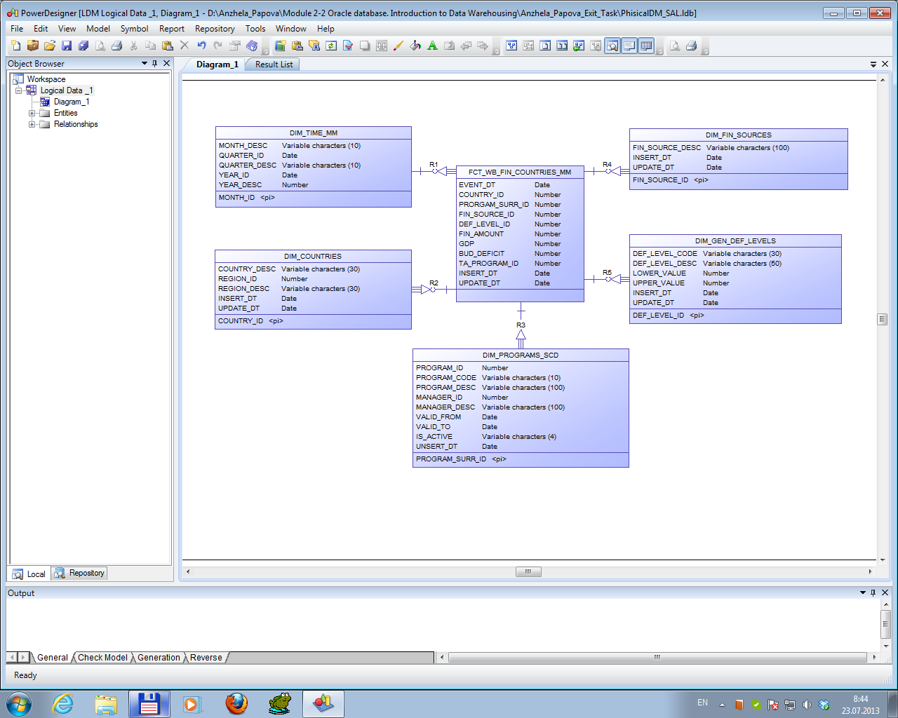

**Figure 4.3. Physical diagram of solution (Star Schema)**

Physical diagram of solution as a Snowflake Schema is presented in Figure 4.4.

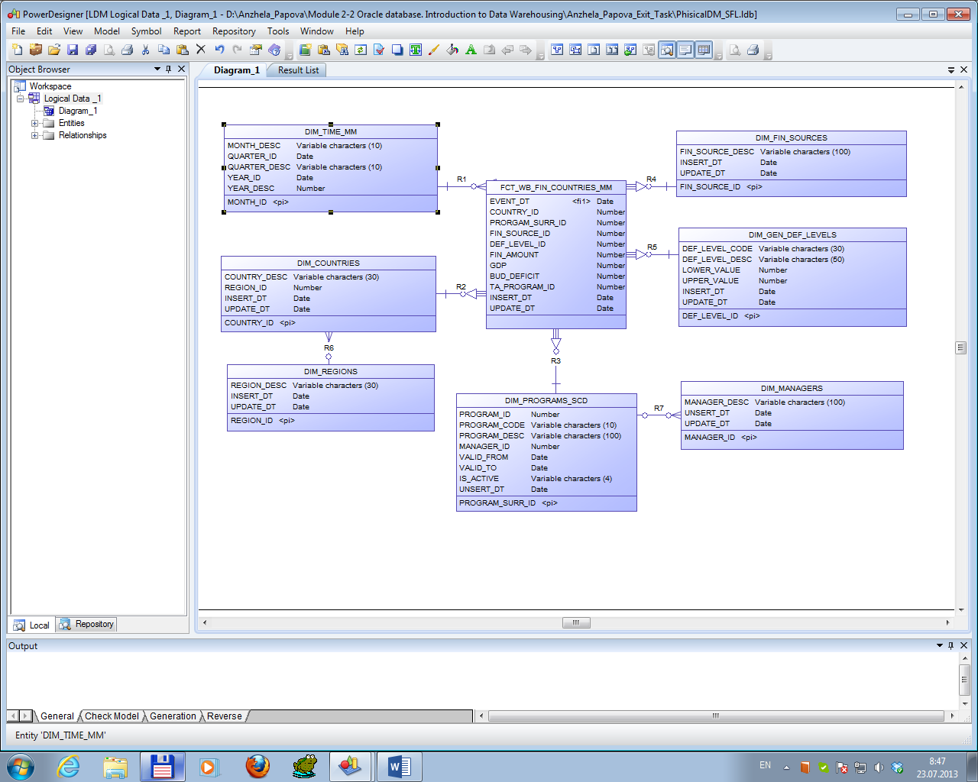

**Figure 4.4. Physical diagram of solution (Snowflake Schema)**

Final solution will be implemented using a Star Schema approach because of the next benefits from using Star Schema:

* Star Schema can easily be augmented by adding new dimensions, as long as they fit in with the fact entity;
* Star Schema rolls subset dimensions into single entities from a multiple dimensional hierarchy of a Snowflake schema. Therefore, the number of joins in queries will be reduced and queries should execute faster.

Preliminary structure of fact entity and dimensional entities was described in chapter 2. As noted above, structure of dimensional and fact entities might be changed during BI Solution Concept creation.